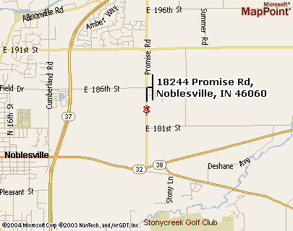

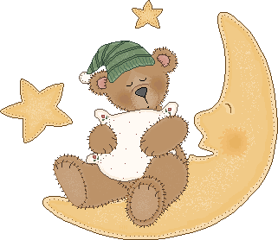




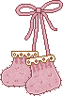
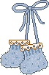
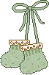


Map to Darlene’s is on the back of this card. The address is 18244 Promise Road in Noblesville.

Come and celebrate the upcoming arrival of two boys and a girl at a Triple Shower!!!

For: Jennifer and the Schlotter Babies
When: April 18th, 2004
Where: Darlene Musselman’s House
Time: 1:00 pm

The babies are registered at Babies R Us, Target and Wal-Mart

Hosted by Darlene Musselman and Kristin Yahnke
(317-773-0231) (317-826-0793)
If you have questions please call one of us.

